**Lavanya Santana S**

**24MCR059**

**DEVOPS TRAINING**

**DAY 5**

**CONFIGURING PIPELINE**

Step 1: Create github repository kubernet and push the cd kubernetes files as frontend ,backend and k8s

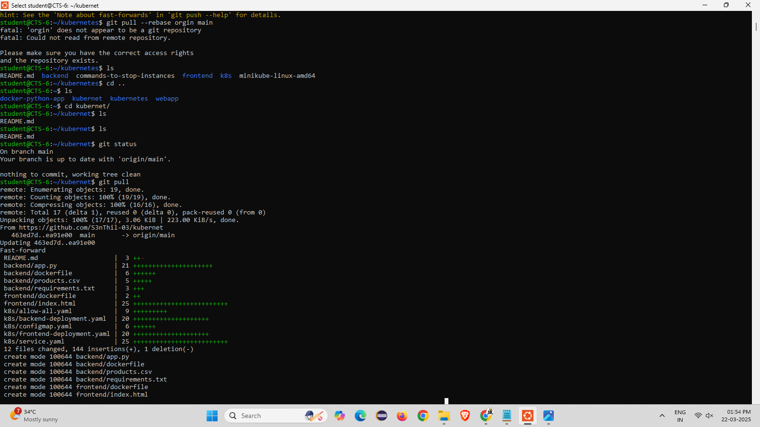

Step 2: create Jenkinsfile and add the following code and push into the github repo kubernet

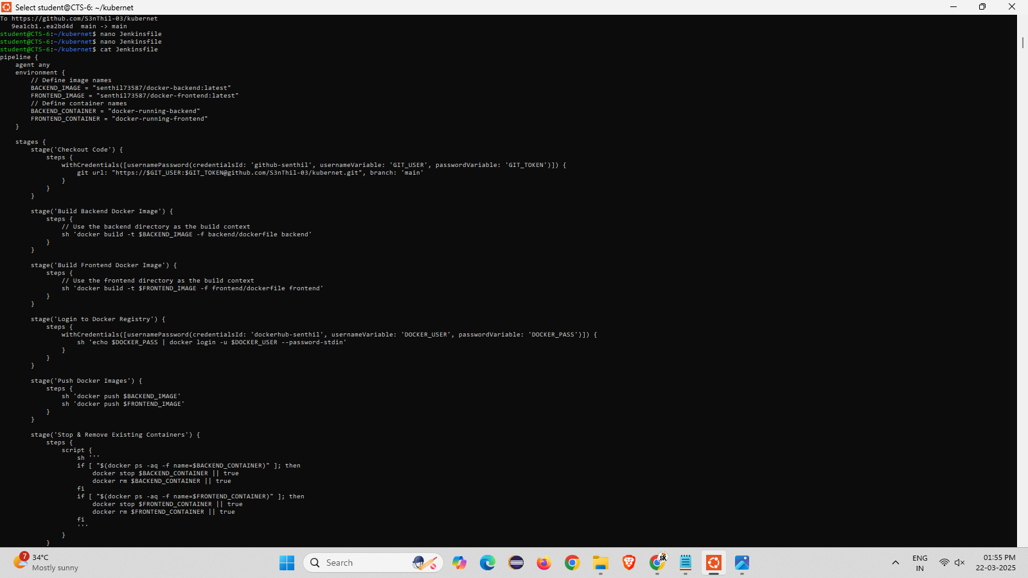

Step 3: Open Jenkins create a item in pipeline and click ok and go to configure add the repo url and credentials and click build

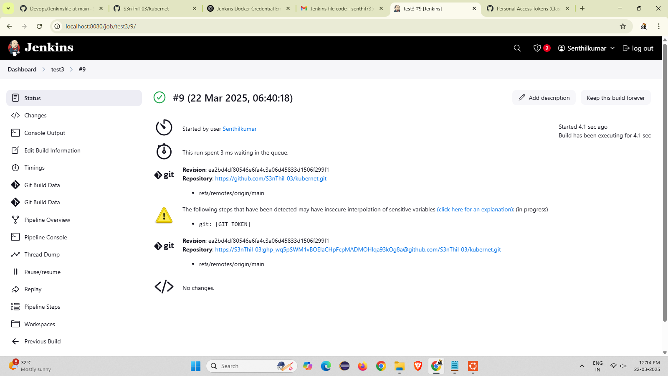

Step 4 : open console output and check build is complete or not.

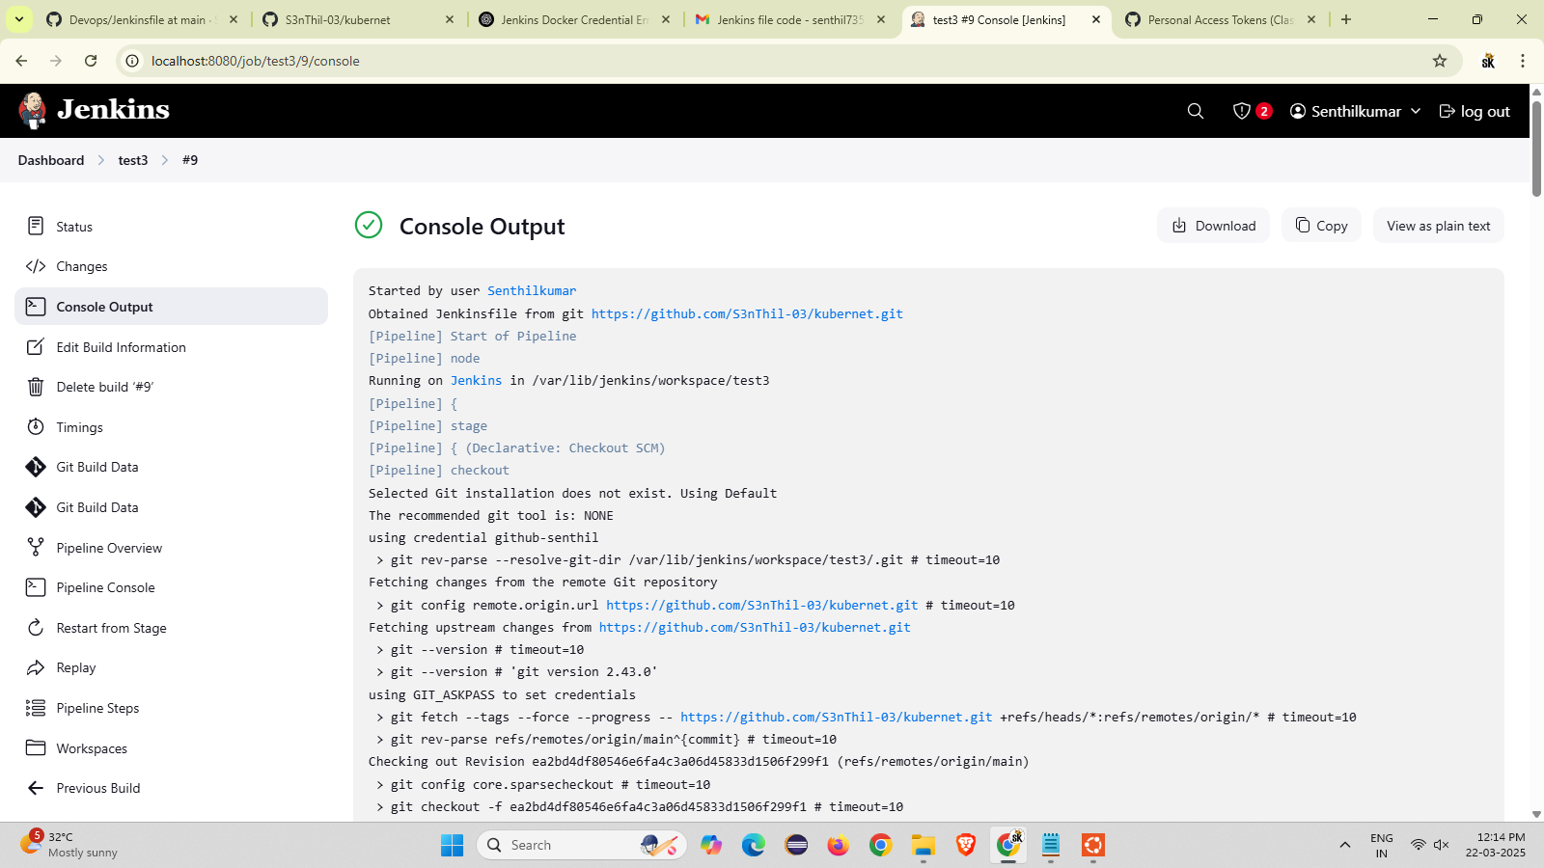

Step 5 : go to dashboard > manage Jenkins > plugins and install the Kubernetes once it all download success will shown